Power BI Data Analytics
3/1/2026
Objective:
- Install & config SQL Server & SSMS
- Implementing data import techniques from various sources into SQL Server and Power BI
- Applying data profiling and cleaning methods to ensure data quality and consistency
- Building calculated columns and custom measures using Data Analysis Expression (DAX) in Power BI
- Analyzing sales, returns, and inventory data to identify trends and patterns
- Designing interactive Power BI reports with effective visualizations to communicate insights
- Optimizing Power BI reports for performance and accessibility

Project Architecture:

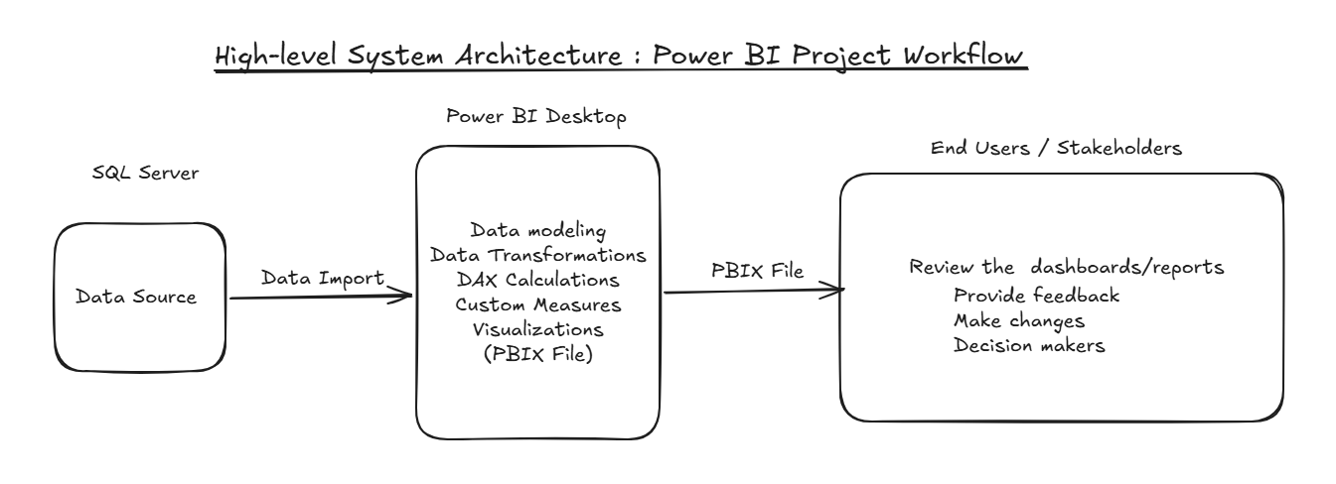

Tech stack:
- Microsoft Power BI Desktop
- SQL Server Management Studio (SSMS)
- Fashion_dataset.csv

Tasks performed:
- Importing the data (fashion_dataset.csv) using “Import Flat File” on database
  - Importing data to SQL server
  - Importing data to Power BI Desktop

- Data Profiling & Cleaning
  - Data Profiling and Data Types
  - Replacing null values
  - Adding Rating Category column

- Data Transformation Steps
  - Data cleaning
  - Adding custom discount column

- Sales Performance & Revenue
  - Total sales KPI card
  - Avg. Order Value & Units Sold
  - Revenue by Brand

- Customer Behavior & Returns
  - Creating report page
  - Return by Return Reasons
  - Number of reasons by season
  - Return Category
  - Returns by Rating Category

- Inventory & Category
  - Creating a Report page – Inventory & Category Performance
  - Stock Quantity by Brand & Category
  - Units Sold by Month
  - Avg. Order Value by Category
  - Avg. Order Value by Brand

- Refresh the Power BI report/dashboard after UPDATE statement from brand = ‘Zara’ to ‘H&M’

Queries:
- CREATE DATABASE PowerBI;
- USE PowerBI;
- SELECT * FROM fashion_dataset;
- UPDATE [dbo].[fashion_dataset] -- to update the table
SET brand='H&M'
WHERE brand='Zara';
Custom Measures:
- % Return
Formula: % Return = (countx(filter(fashion_dataset,fashion_dataset[is_returned] = TRUE()),fashion_dataset[product_id]) / COUNTROWS (fashion_dataset)) * 100
- Avg. Order Value
Formula: Avg. Order Value = SUM (fashion_dataset[current_price]) / COUNT (fashion_dataset[product_id])
Visuals used:
- Stacked bar chart
- Clustered column chart
- Line chart
- Pie chart
- Ribbon chart
- Card(s)
- Slicer
Power BI Pages created:
- SALES PERFORMANCE AND REVENUE
- CUSTOMER BEHAVIOR & RETURNS
- INVENTORY & CATEGORY PERFORMANCE
Page1: SALES PERFORMANCE AND REVENUE
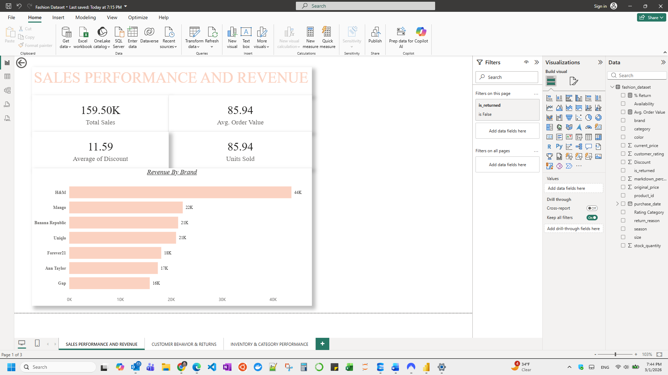

Page2: CUSTOMER BEHAVIOR & RETURNS
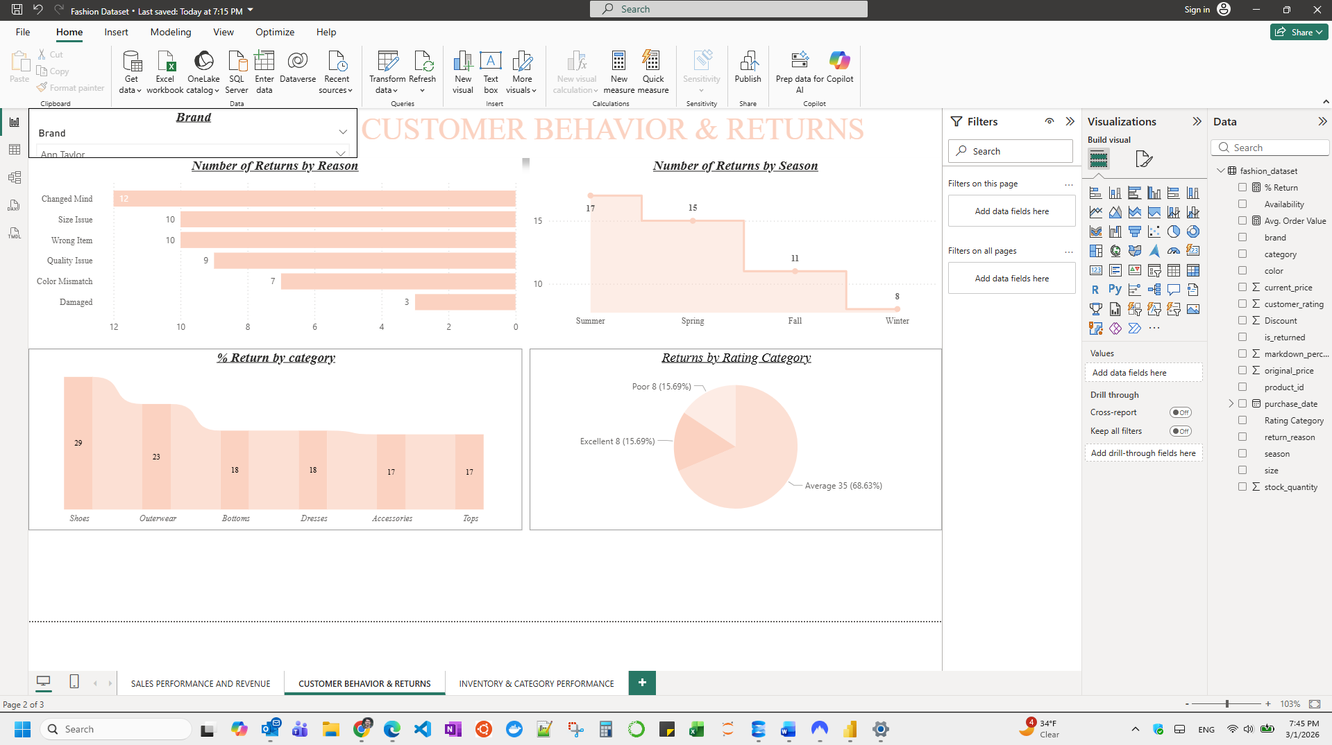
Page3: INVENTORY & CATEGORY PERFORMANCE
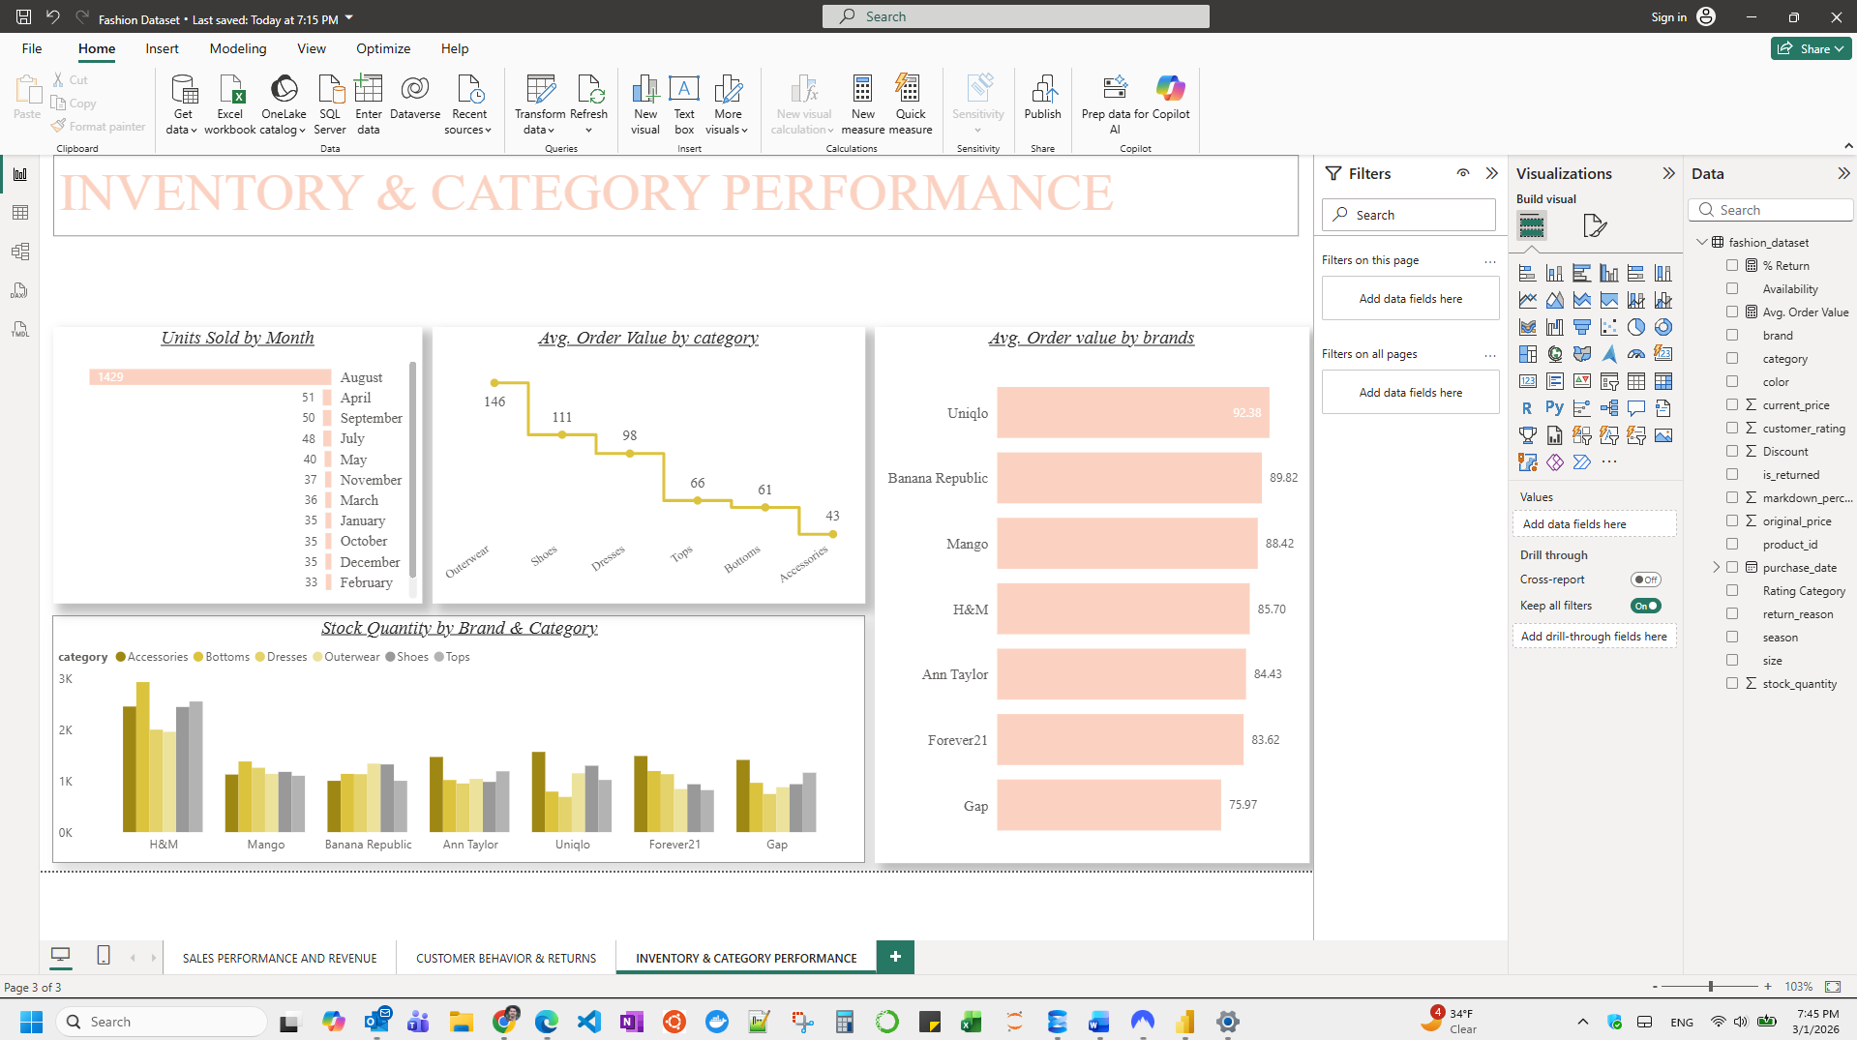

Data Model in Power BI:
SQL Server:
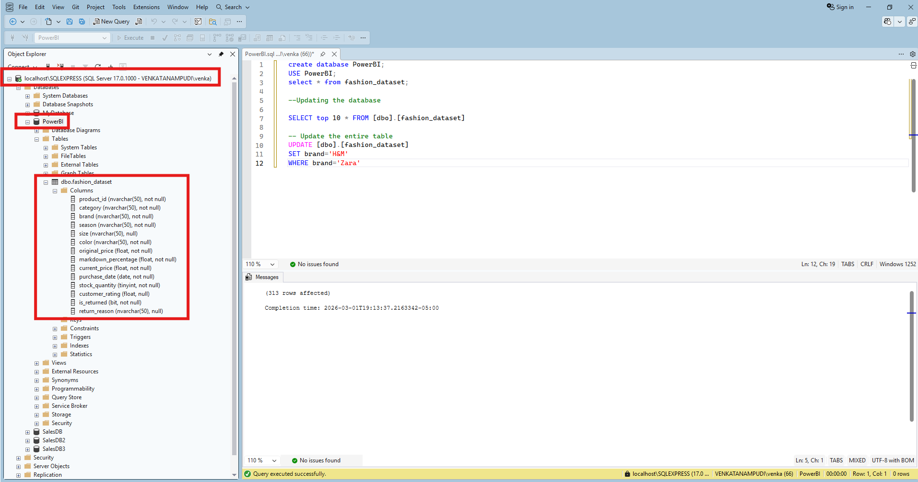

-----------------------------------------------------------END---------------------------------------------------

